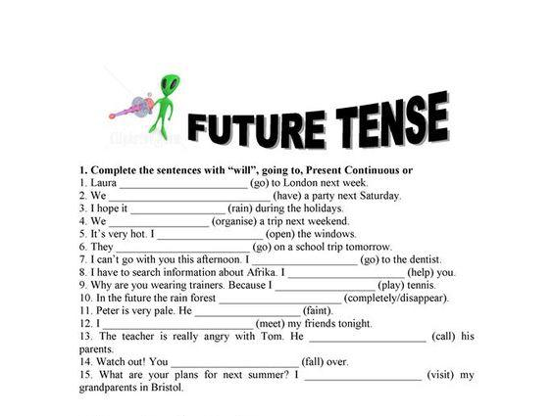

Answer

Answer

Answer

Answer

Answer

Answer

Answer

Answer

Answer

Answer

Answer

Answer

Answer

Answer

Answer