INGLÊS

PROFESSORA VERA FREITAS UNIT 01 – LESSON 01

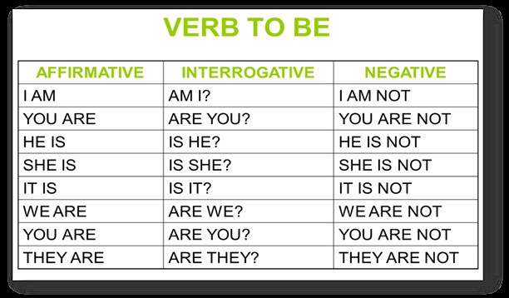

Verb ‘to be’ Exercises:

- Complete with the full form of the verb ‘to be’.
  - I _____a student.
ANSWER
  - He _____a teacher.
ANSWER
  - She _____a journalist.
ANSWER
  - It _______a book.
ANSWER
  - We _____mechanics.
ANSWER
  - You _____pilots.
ANSWER
  - They _____policemen.
ANSWER

- Complete with the contracted form of the verb ‘to be’.
  - I _____young.
ANSWER
  - He _____handsome.
ANSWER
  - She _____beautiful.
ANSWER
  - It _____a pencil.
ANSWER
  - We _____friends.
ANSWER
  - You _____students.
ANSWER
  - They _____happy.
ANSWER

- Complete with the correct form of the verb ‘to be’.
ANSWER
  - It _____cold today.
  - I _____at home now.
ANSWER
  - They _____Korean.
ANSWER
  - There _____a pen on the desk.
ANSWER
  - My name _____Nikita.
ANSWER
  - We _____from Ukraine.
ANSWER
  - That _____right.
ANSWER
  - I _____OK, thanks.
ANSWER
  - Clara and Steve _____married.
ANSWER
  - She _____an English teacher.
ANSWER

2

Fill in the blanks with “is”, “am” or “are”.

- Her name _____ Tess.
ANSWER
- I _____ hungry and tired.
ANSWER
- You _____ late, Tommy!
ANSWER
- Our class teacher _____ nice and friendly.
ANSWER
- The kids _____ naughty.
ANSWER
- Your jokes _____ funny.
ANSWER
- Brenda _____ a happy girl.
ANSWER
- Your house _____ very big.
ANSWER
- We _____ sleepy.
ANSWER
- This bag _____ heavy.
ANSWER
- Tiffany and Holly _____ my sisters.
ANSWER
- That girl _____ pretty.
ANSWER
- It _____ an exciting movie.
ANSWER
- The mangoes _____ sweet.
ANSWER

3

Possessive Adjectives

Fill in the blanks with the correct word

MY YOUR HIS HER ITS OUR THEIR

- The boy likes _______ school.
ANSWER
- Mary sees _______ mother every day.
ANSWER
- My teachers bring _______ children to our place on Saturdays.
ANSWER
- The cat eats _______ food quickly.
ANSWER
- I often forget _______ key.
ANSWER
- You write in _______ book in class.
ANSWER
- We bring _______ pencils to class.
ANSWER
- The men always bring _______ wives to the party.
ANSWER
ANSWER
- Mr Adams teaches _______ class in the morning.
- She likes to give presents to _______ grandchildren.
ANSWER
- They never do _______ homework.
ANSWER
- Ali sometimes wear _______ green t-shirt.
ANSWER
- We love _______ school.
ANSWER
- Ayse and Ahmet play with _______ sisters.
ANSWER
- You always wear _______ uniform at school.
ANSWER
- I rarely walk to _______ school.
ANSWER
- We eat _______ lunch at 12 a.m.
ANSWER
- The bird always sleeps in _______ nest.
ANSWER
- She always forget _______ books in the cupboard.
ANSWER
ANSWER
- He often speaks to _______ friends.
- They close _______ books.
ANSWER
4

