INGLÊS

PROFESSORA VERA FREITAS UNIT 01 – LESSON 03

**ANS**

**ANS**

**ANS**

**ANS**

**ANS**

**ANS**

**ANS**

**ANS**

**ANS**

**ANS**

**ANSWER**

**ANSWER**

**ANSWER**

**ANSWER**

**ANSWER**

**ANSWER**

**ANSWER**

**ANSWER**

**ANSWER**

**ANSWER**

**ANSWER**

**ANSWER**

**ANSWER**

**ANSWER**

**ANSWER**

**ANSWER**

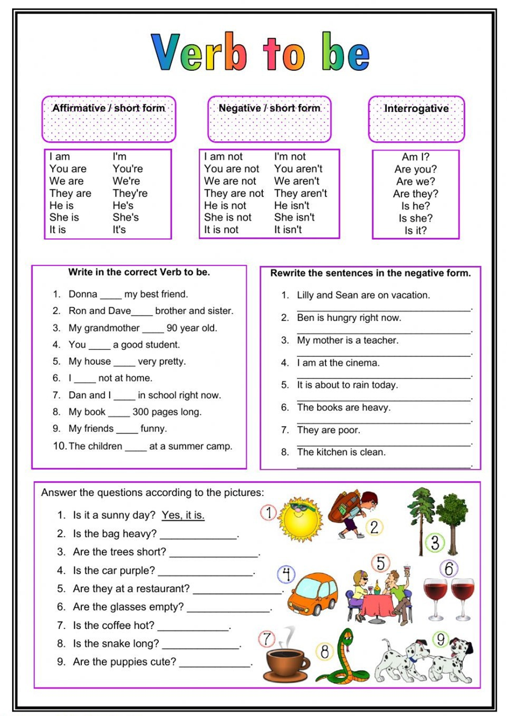

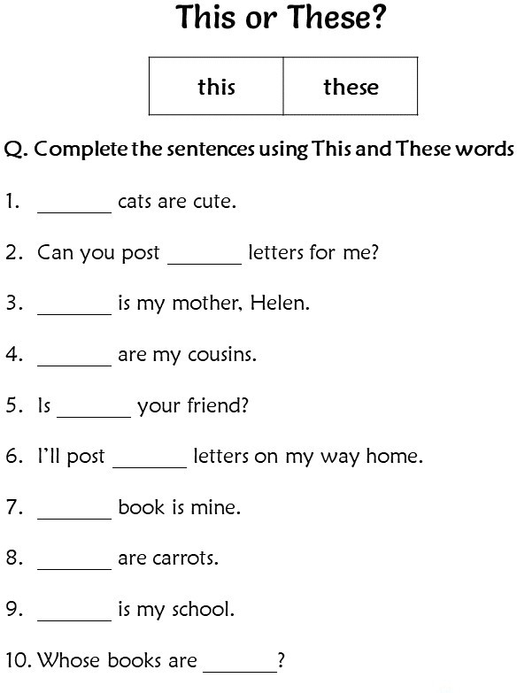

**ANSWER**

**ANSWER**

**ANSWER**

**ANSWER**

**ANSWER**

**ANSWER**

**ANSWER**

**ANSWER**

**ANSWER**

**ANSWER**

# 2

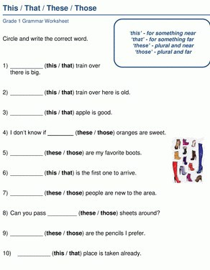

**ANSWER**

**ANSWER**

**ANSWER**

**ANSWER**

**ANSWER**

**ANSWER**

**ANSWER**

**ANSWER**

**ANSWER**

**ANSWER**

3

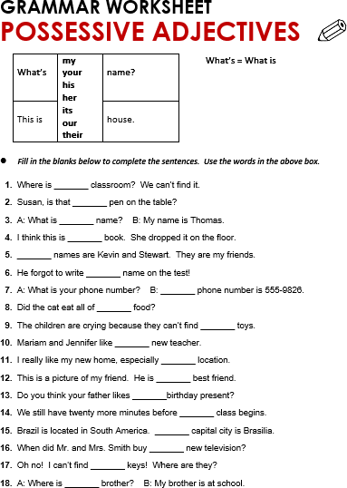

**ANSWER**

**ANSWER**

**ANSWER**

**ANSWER**

**ANSWER**

**ANSWER**

**ANSWER**

**ANSWER**

**ANSWER**

**ANSWER**

**ANSWER**

**ANSWER**

**ANSWER**

**ANSWER**

**ANSWER**

**ANSWER**

**ANSWER**

**ANSWER**

# 4