INGLÊS

PROFESSORA VERA FREITAS UNIT 02 – LESSON 02

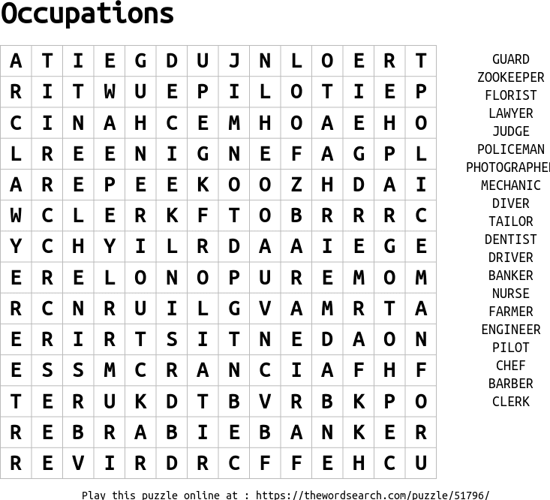

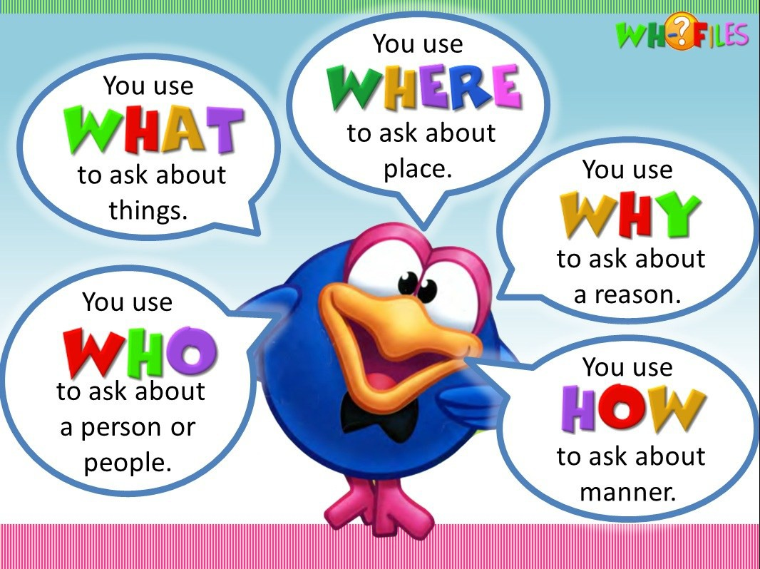

# 2

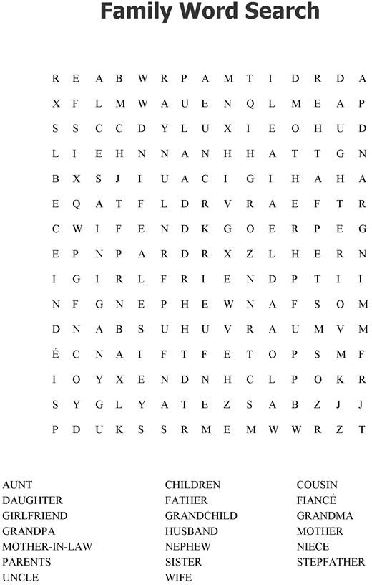

3

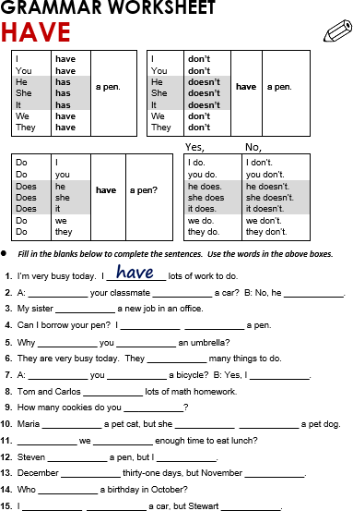

**ANSWER**

**ANSWER**

**ANSWER**

**ANSWER**

**ANSWER**

**ANSWER**

**ANSWER**

**ANSWER**

**ANSWER**

**ANSWER**

**ANSWER**

**ANSWER**

**ANSWER**

**ANSWER**

**ANSWER**

**ANSWER**

**ANSWER**

**ANSWER**

**ANSWER**

**ANSWER**

**ANSWER**

**ANSWER**

**ANSWER**

**ANSWER**

**ANSWER**

**ANSWER**

**ANSWER**

# 4

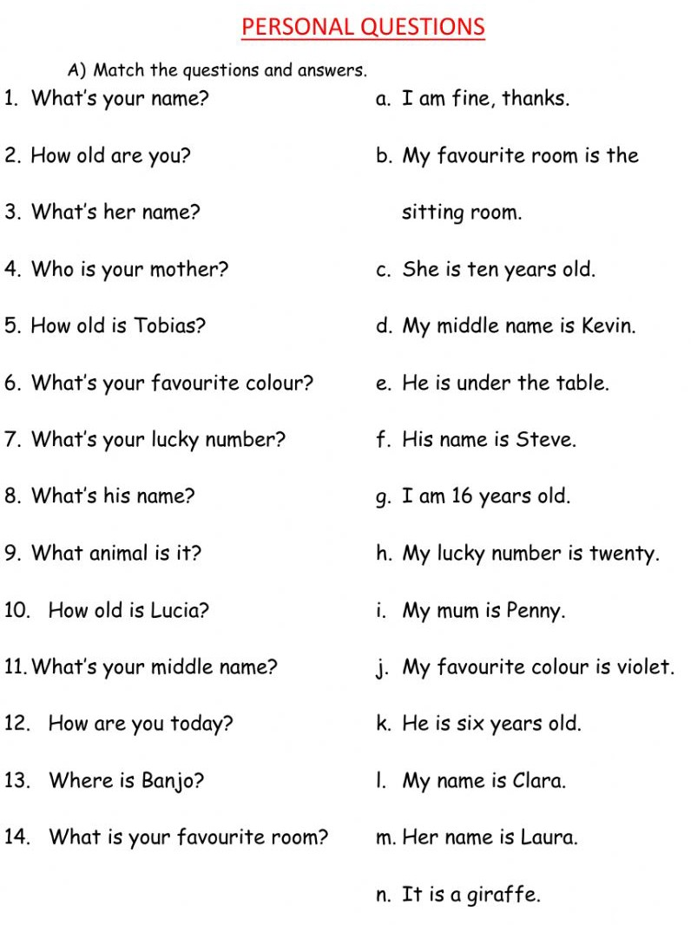

5

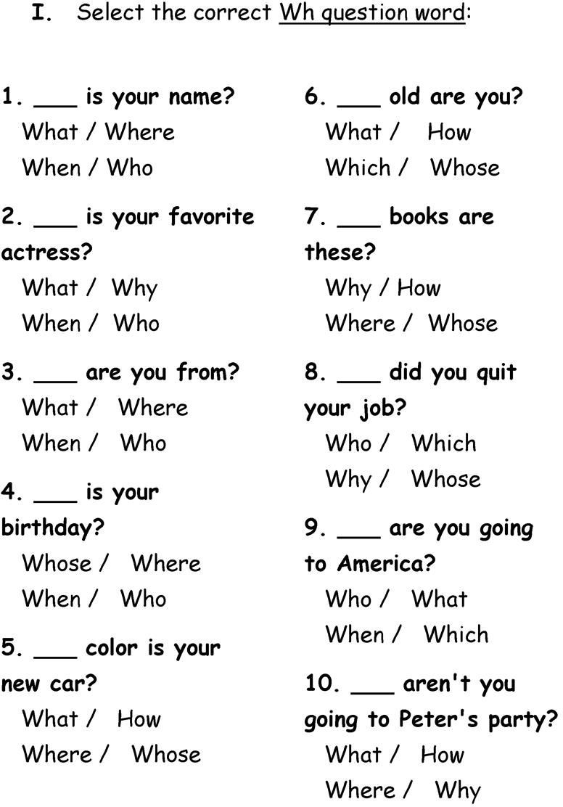

**ANS**

**ANS**

**ANS**

**ANS**

**ANS**

**ANS**

**ANS**

**ANS**

**ANS**

**ANS**

# 6