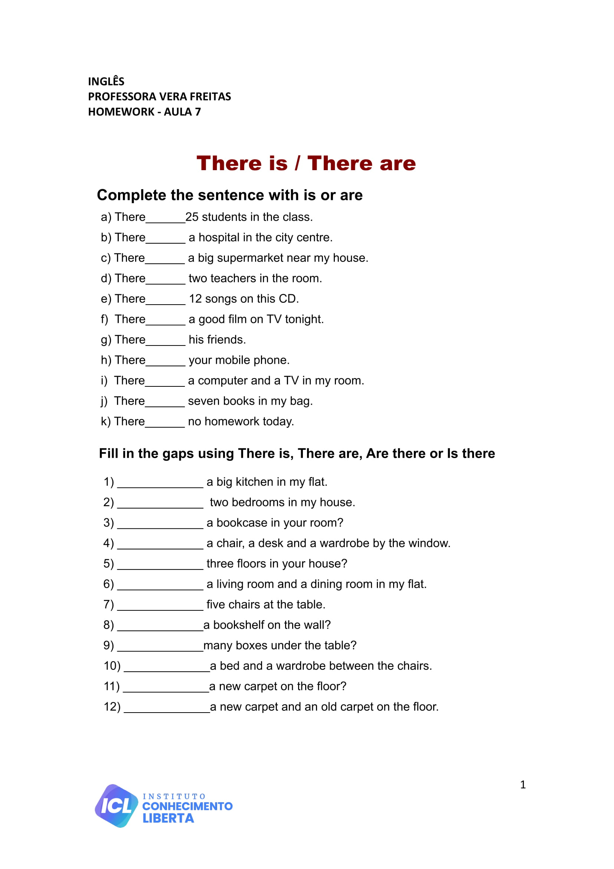

**UNIT 03 - LESSON 01**

**ANSWER**

**ANSWER**

**ANSWER**

**ANSWER**

**ANSWER**

**ANSWER**

**ANSWER**

**ANSWER**

**ANSWER**

**ANSWER**

**ANSWER**

**ANSWER**

**ANS**

**ANS**

**ANS**

**ANS**

**ANS**

**ANS**

**ANS**

**ANS**

**ANS**

**ANS**

**ANS**