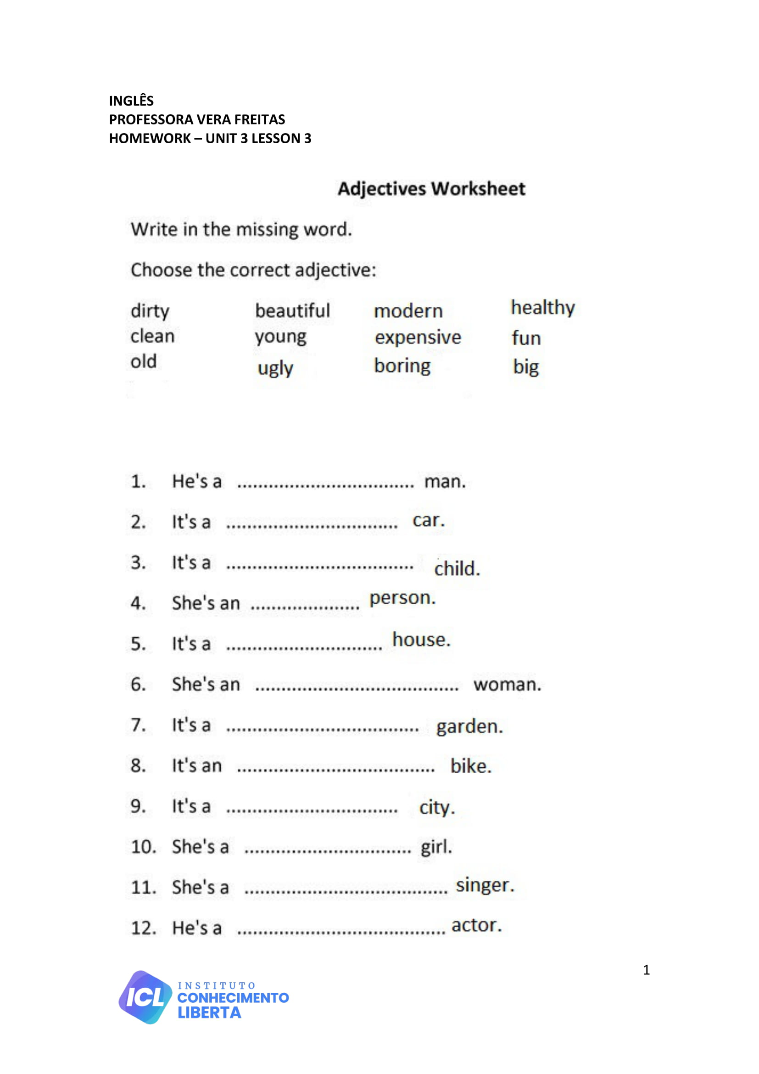

**UNIT 03 - LESSON 03**

**ANSWER**

**ANSWER**

**ANSWER**

**ANSWER**

**ANSWER**

**ANSWER**

**ANSWER**

**ANSWER**

**ANSWER**

**ANSWER**

**ANSWER**

**ANSWER**

