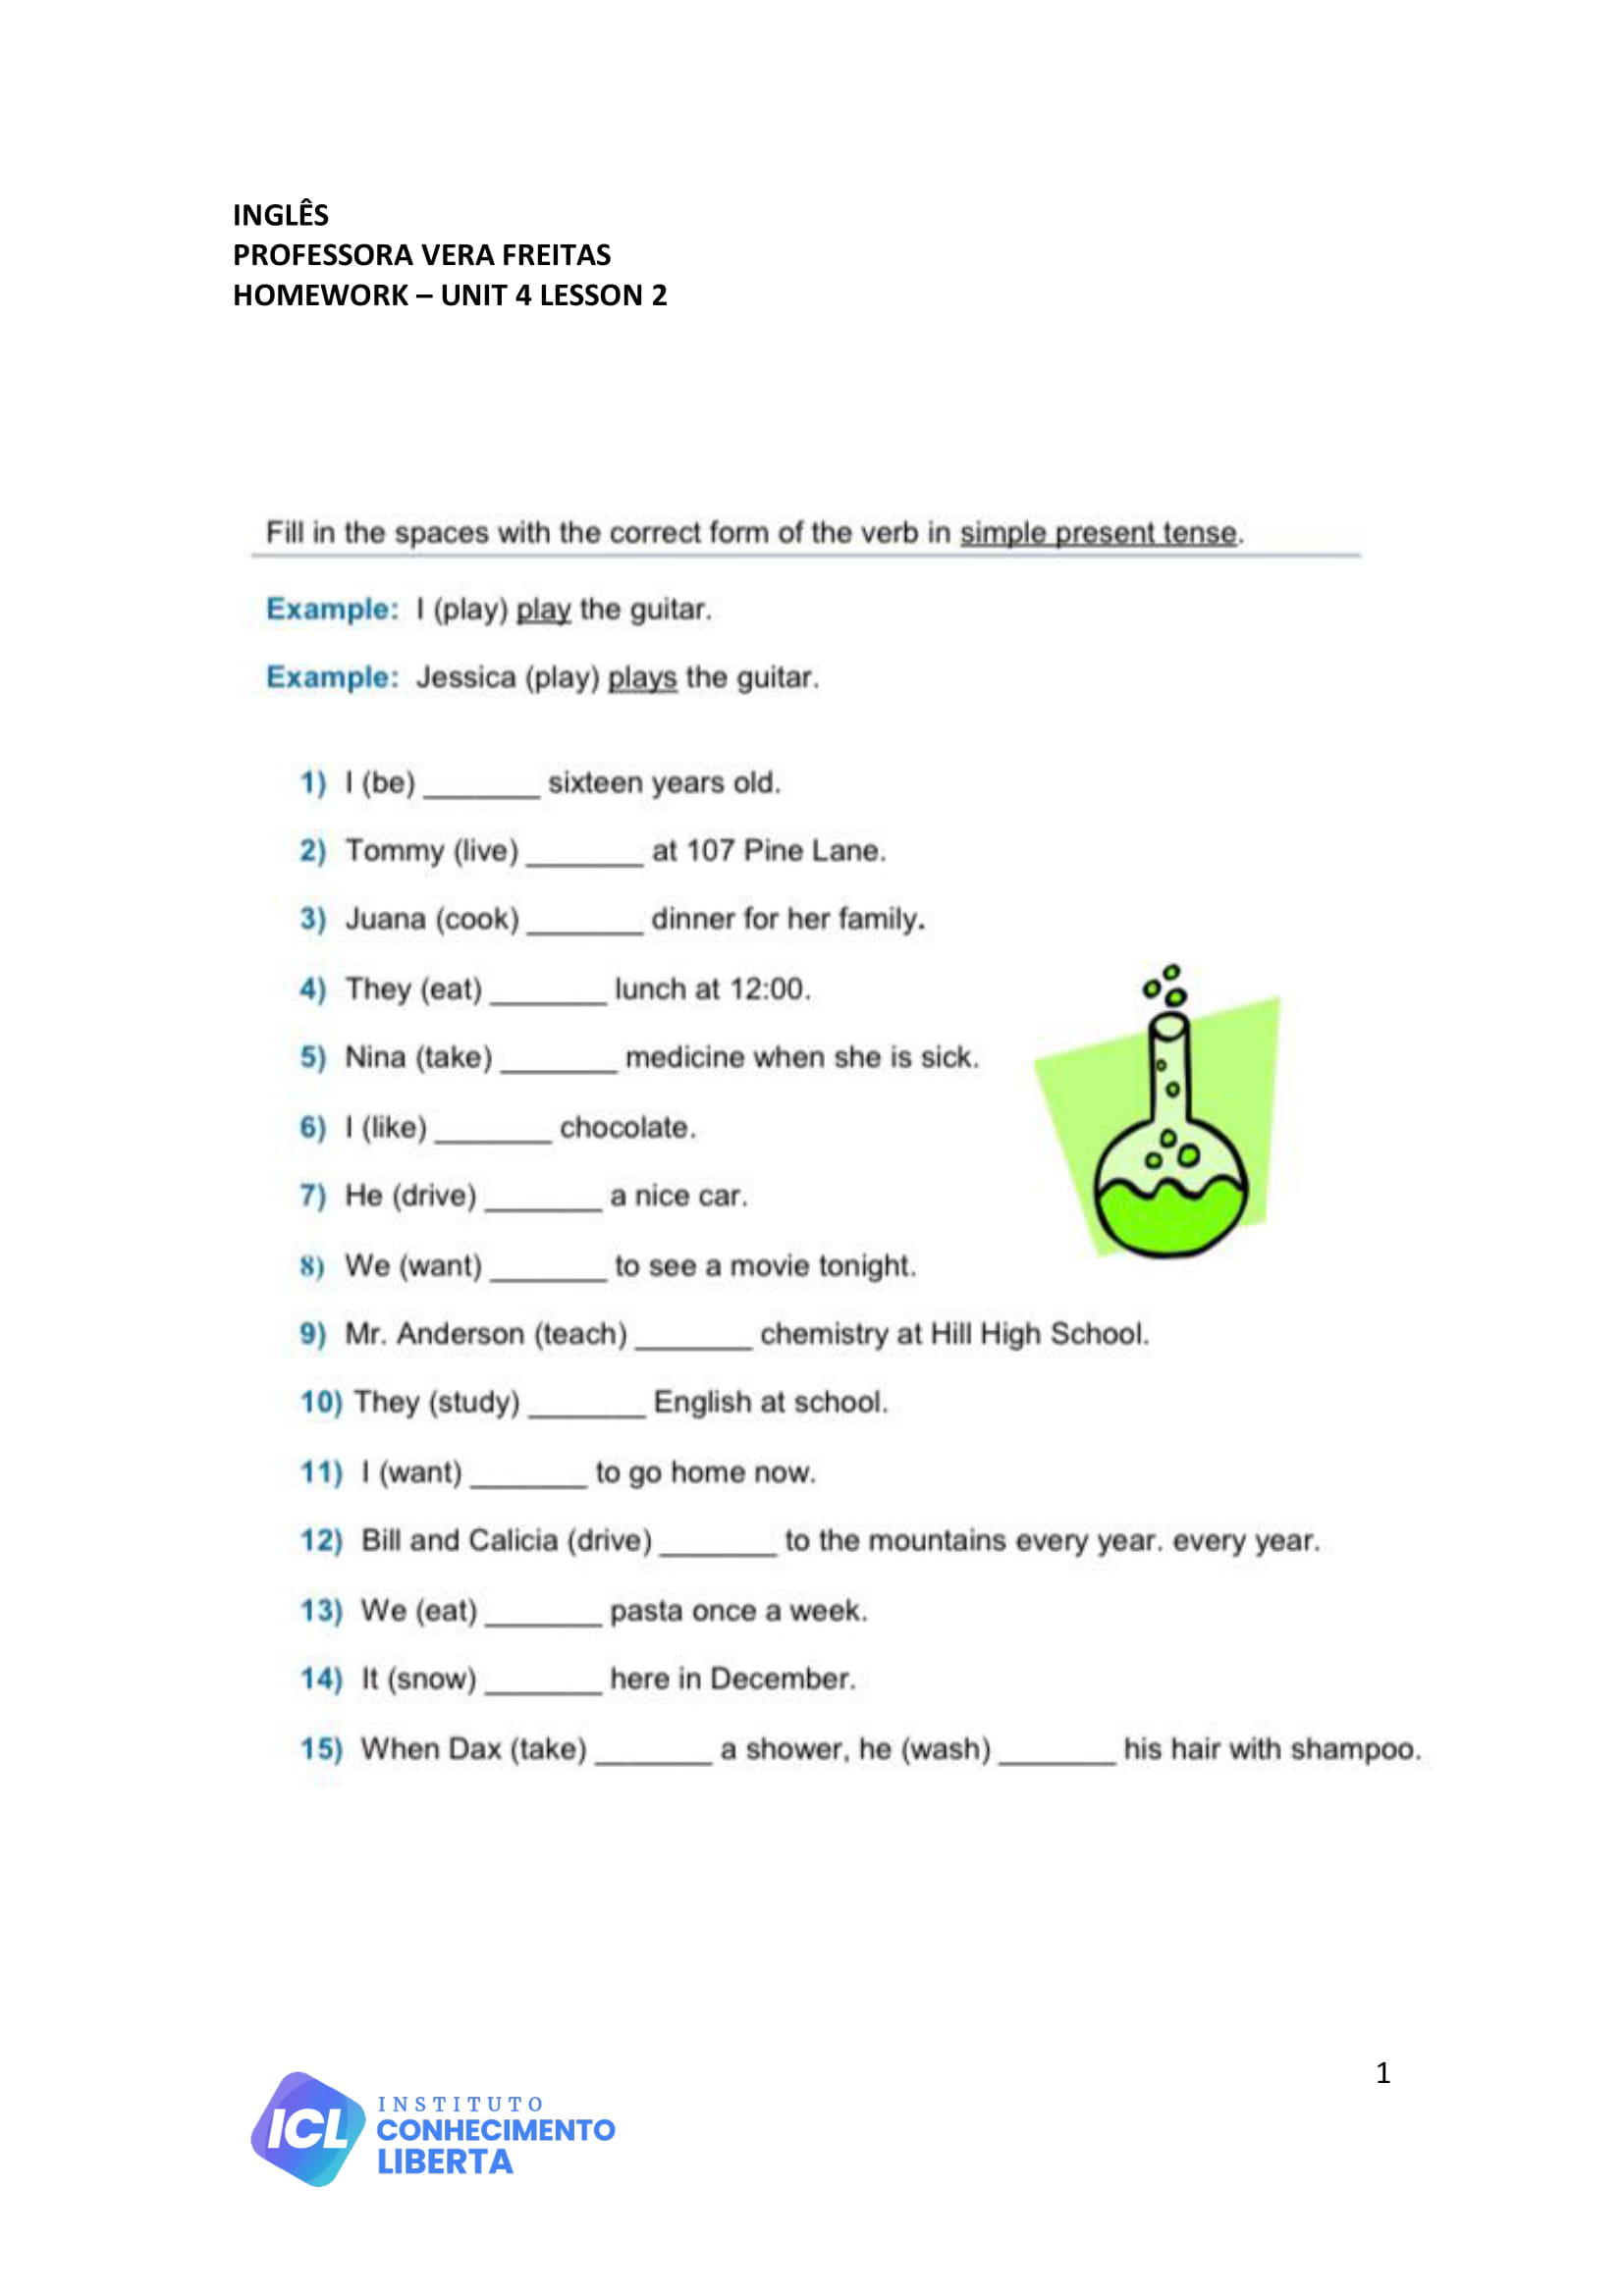

**UNIT 04 - LESSON 02**

**ANSWER**

**ANSWER**

**ANSWER**

**ANSWER**

**ANSWER**

**ANSWER**

**ANSWER**

**ANSWER**

**ANSWER**

**ANSWER**

**ANSWER**

**ANSWER**

**ANSWER**

**ANSWER**

**ANSWER**

**ANSWER**

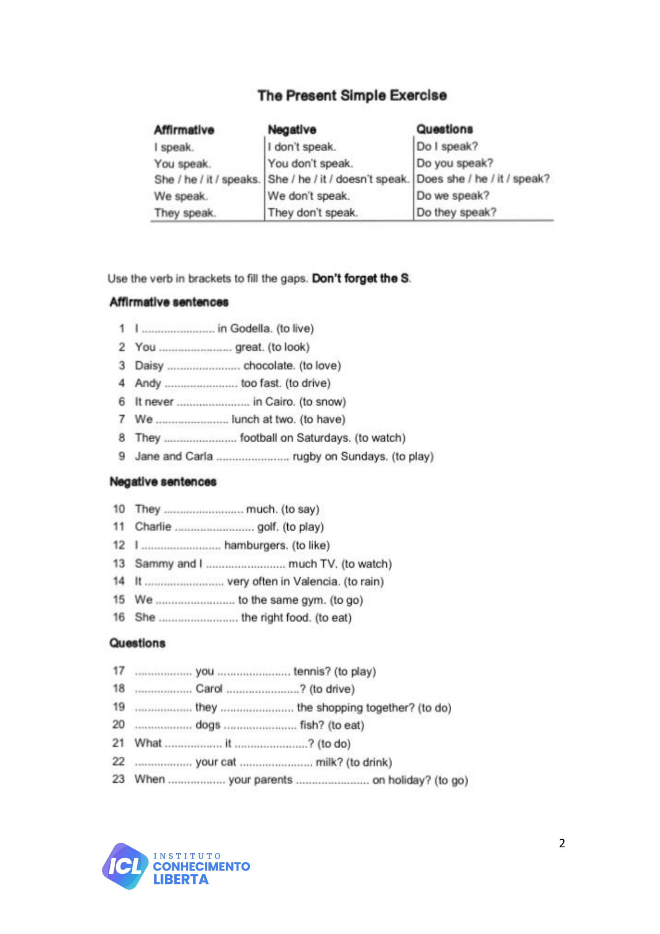

**ANSWER**

**ANSWER**

**ANSWER**

**ANSWER**

**ANSWER**

**ANSWER**

**ANSWER**

**ANSWER**

**ANSWER**

**ANSWER**

**ANSWER**

**ANSWER**

**ANSWER**

**ANSWER**

**ANSWER**

**ANSWER**

**ANSWER**

**ANSWER**

**ANSWER**

**ANSWER**

**ANSWER**

**ANSWER**

**ANSWER**

**ANSWER**

**ANSWER**

**ANSWER**

**ANSWER**

**ANSWER**

**ANSWER**