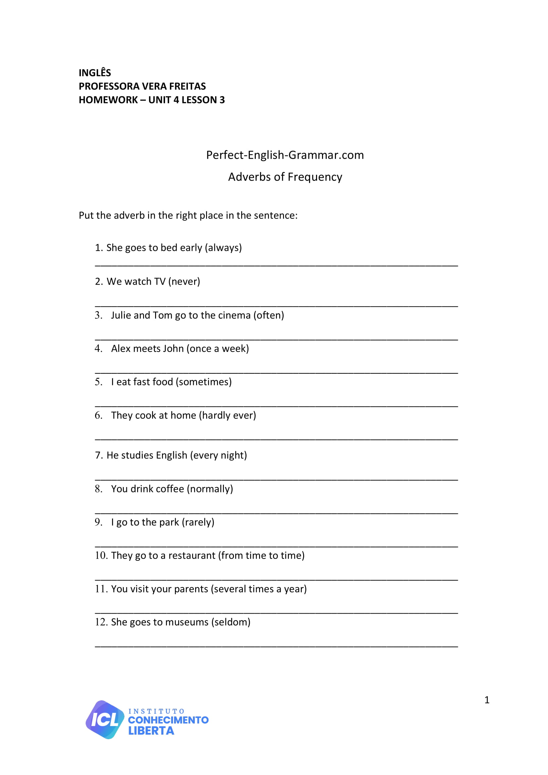

**UNIT 04 - LESSON 03**

**ANSWER**

**ANSWER**

**ANSWER**

**ANSWER**

**ANSWER**

**ANSWER**

**ANSWER**

**ANSWER**

**ANSWER**

**ANSWER**

**ANSWER**

**ANSWER**