INGLÊS
PROFESSORA VERA FREITAS
UNIT 05 - LESSON 02

Prepositions
ANSWER
1. There is a parrot _________________ the cage.
ANSWER
2. The ball is _________________ the table.
ANSWER
3. The pictures are _________________ the wall.
ANSWER
4. The woman is _________________ the dog and the cat.
ANSWER
5. The woman is _________________ the sofa.
ANSWER
6. The table is _________________ the door.
ANSWER
7. The umbrella is _________________ the sofa.

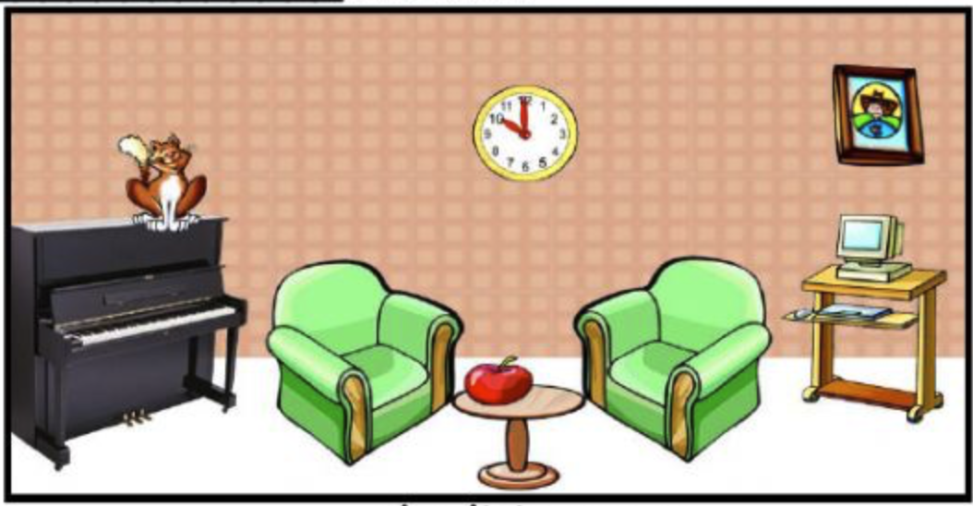
ANSWER
8. There is a piano _________________ the living room.
ANSWER
9. The apple is _________________ the table.
ANSWER
10. The clock is _________________ the wall.
ANSWER
11. The computer is _________________ the armchair.
ANSWER
12. The table is _________________ the armchairs.
ANSWER
13. There is a cat _________________the piano.
ANSWER
14. There is a picture _________________ the wall.

PREPOSITIONS OF PLACE

True or False

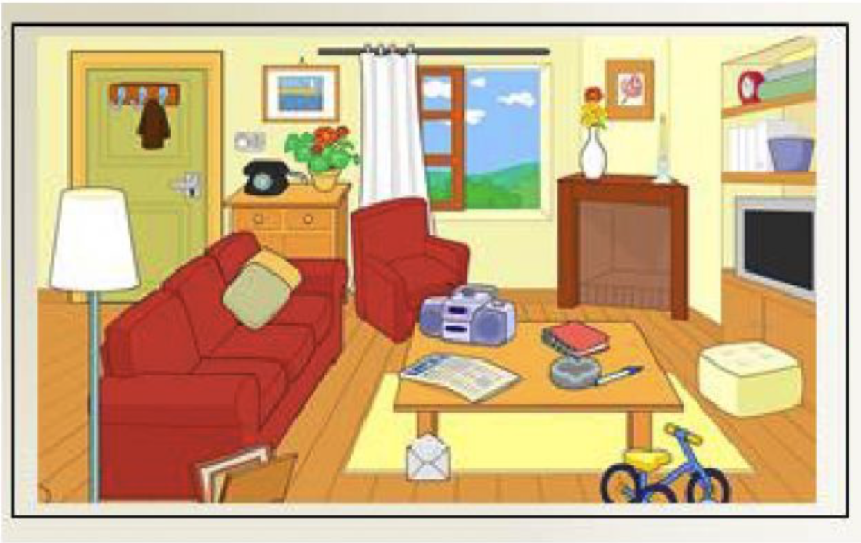
- The radio is in the table. TRUE FALSE
- The telephone is behind the plant. TRUE FALSE
- The book is on the table. TRUE FALSE
- The lamp is under the sofa. TRUE FALSE
- The TV is front of the sofa. TRUE FALSE
- The clock is on the books. TRUE FALSE
- The bike is behind the sofa. TRUE FALSE
- The rug is under the table. TRUE FALSE
- The pillows are in the sofa. TRUE FALSE

