Subject and Object Pronouns Exercise
INGLÊS
PROFESSORA VERA FREITAS
UNIT 07 – LESSON 03

- Choose the correct pronoun
- I / me like London.
- The children are as hungry as we / us.
- All the students passed except I / me.
- A: Who’s there? B: I / Me!
- They / them love vegan food.
- A: Is that the man you told me about? B: Yes, that’s he / him.
- We all like cake except she / her.
- He / him will get a new phone soon.
- His sister isn’t as tall as he / him.
- Is that chocolate for I / me?
- She / her wants to go home early.
- Everyone arrived on time but he / him.
- Please keep up with we / us.
- A: Who ate all the chocolate? B: She / Her!
- We / us have been to Rio.
- Could you pass the coffee to she / her?
- My brother is taller than I / me.
- I / me went to the bookshop yesterday.
- Our new teacher is friendlier than she / her.
- All the children came inside except they / them.
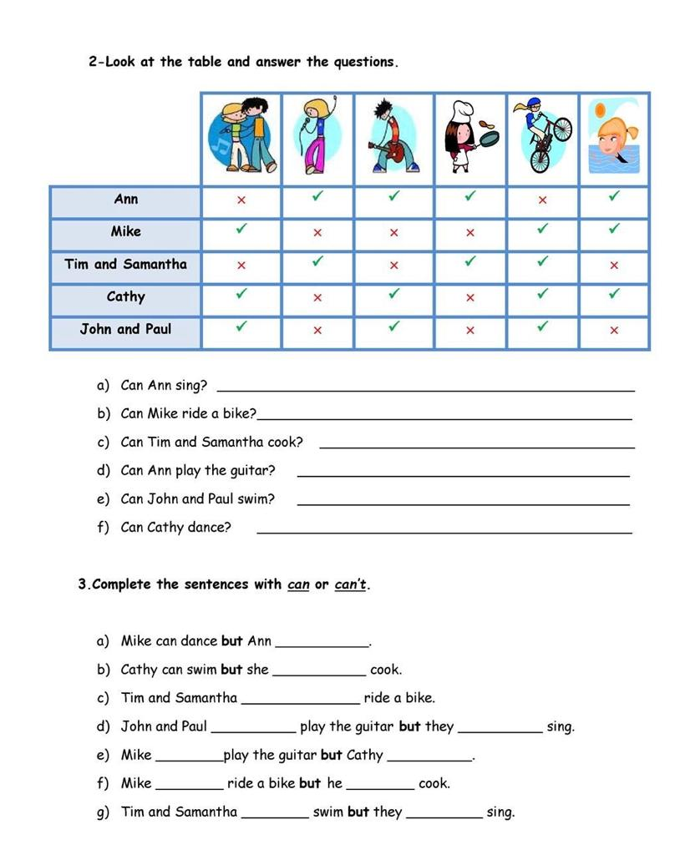
ANSWER
ANSWER
ANSWER
ANSWER
ANSWER
ANSWER
ANSWER
ANSWER
ANSWER
ANSWER
ANSWER
ANSWER
ANSWER
ANSWER
ANSWER
ANSWER
ANSWER
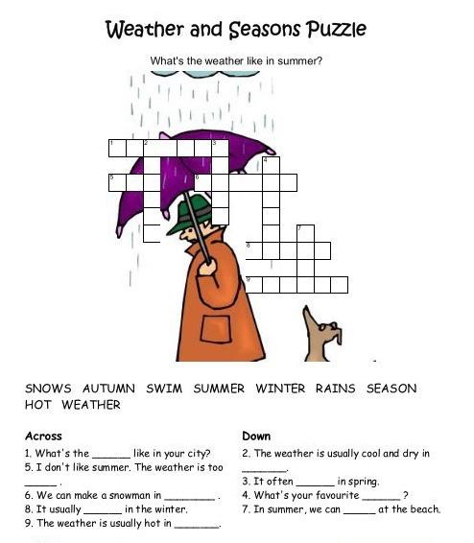
ANSWER
ANSWER
ANSWER
ANSWER
ANSWER
ANSWER
ANSWER
ANSWER
ANSWER
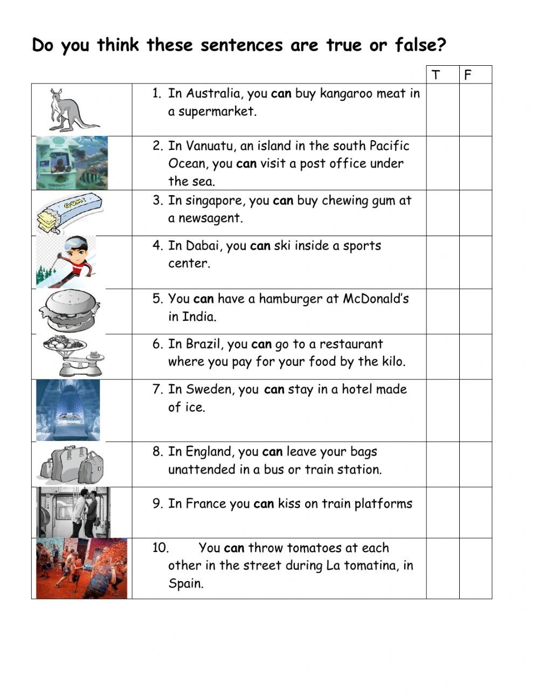

Finish!!

