INGLÊS  
PROFESSORA VERA FREITAS  
UNIT 08 – LESSON 01

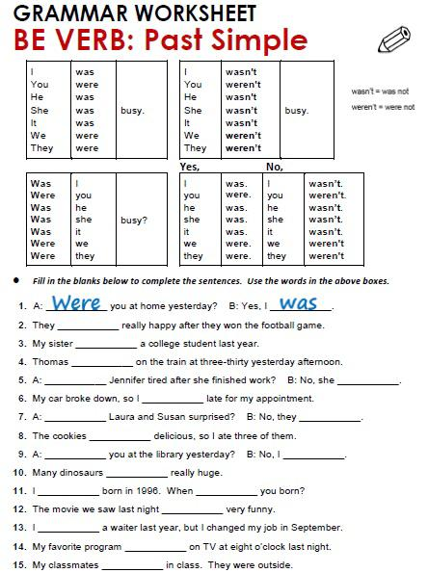

ANSWER

ANSWER

ANSWER

ANSWER

ANSWER

ANSWER

ANSWER

ANSWER

ANSWER

ANSWER

ANSWER

ANSWER

ANSWER

ANSWER

ANSWER

ANSWER

ANSWER

ANSWER

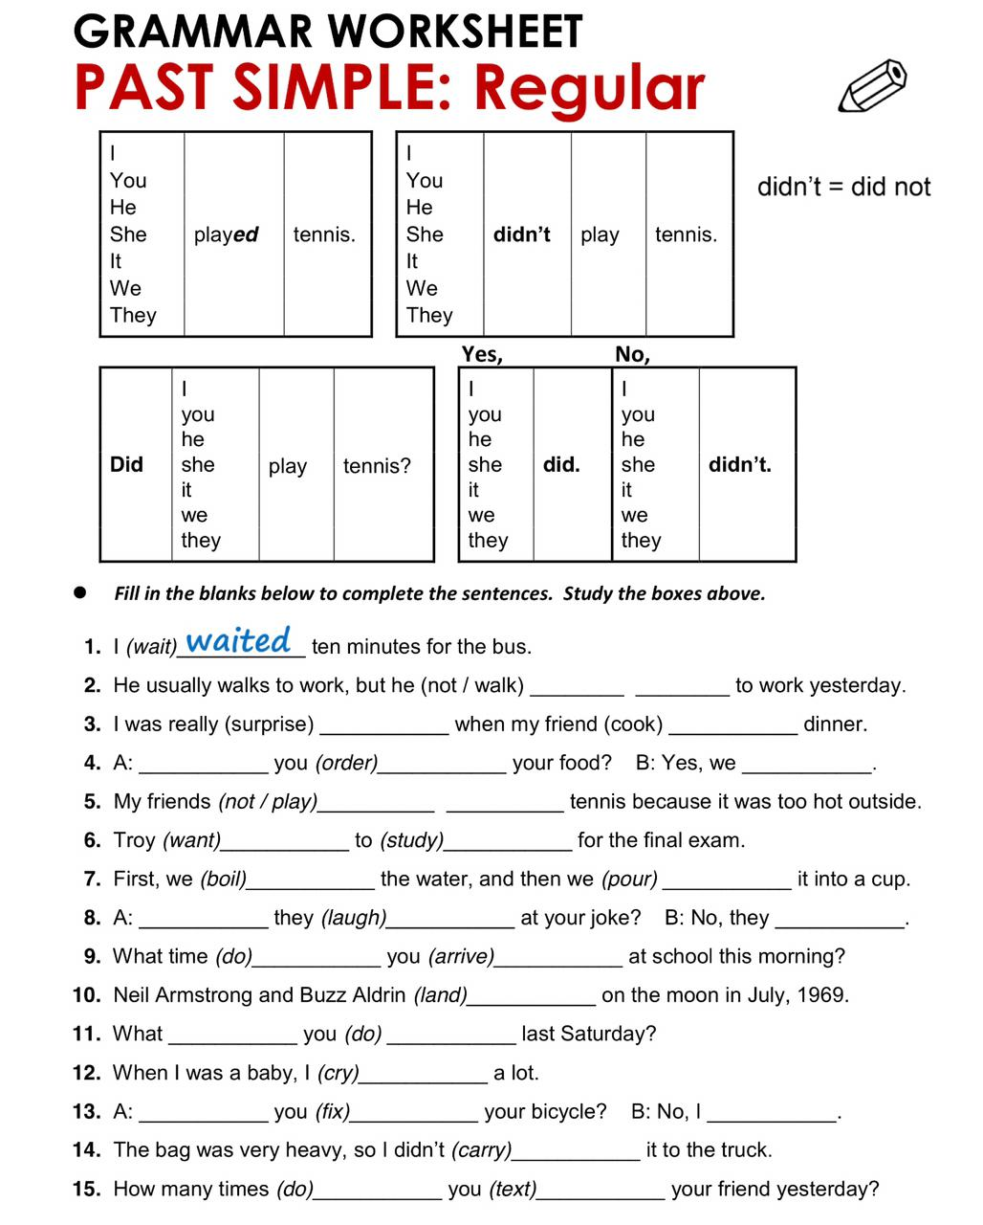

ANSWER

ANSWER

ANSWER

ANSWER

ANSWER

ANSWER

ANSWER

ANSWER

ANSWER

ANSWER

ANSWER

ANSWER

ANSWER

ANSWER

ANSWER

ANSWER

ANSWER

ANSWER

ANSWER

ANSWER

ANSWER

ANSWER

ANSWER

ANSWER

ANSWER

ANSWER

ANSWER

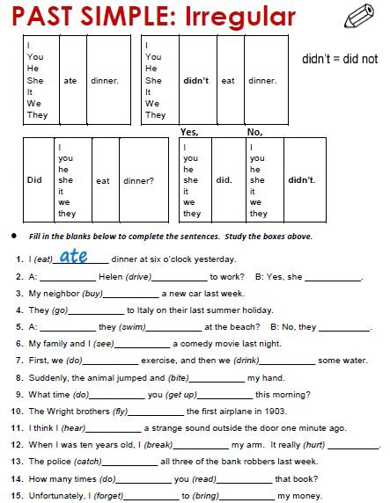

ANSWER

ANSWER

ANSWER

ANSWER

ANSWER

ANSWER

ANSWER

ANSWER

ANSWER

ANSWER

ANSWER

ANSWER

ANSWER

ANSWER

ANSWER

ANSWER

ANSWER

ANSWER

ANSWER

ANSWER

ANSWER

ANSWER

ANSWER

