INGLÊS  
PROFESSORA VERA FREITAS  
UNIT 09 – LESSON 03

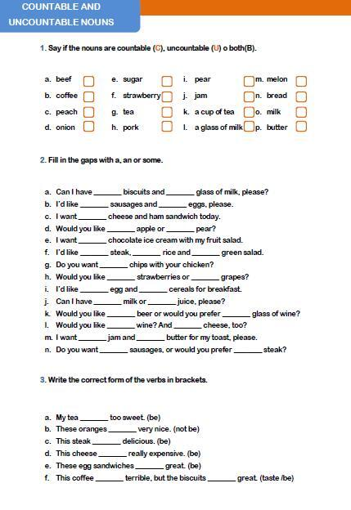

ANSWER

ANSWER

ANSWER

ANSWER

ANSWER

ANSWER

ANSWER

ANSWER

ANSWER

ANSWER

ANSWER

ANSWER

ANSWER

ANSWER

ANSWER

ANSWER

ANSWER

ANSWER

ANSWER

ANSWER

ANSWER

ANSWER

ANSWER

ANSWER

ANSWER

ANSWER

ANSWER

ANSWER

ANSWER

ANSWER

ANSWER

ANSWER

ANSWER