INGLÊS  
PROFESSORA VERA FREITAS  
UNIT 09 – LESSON 02

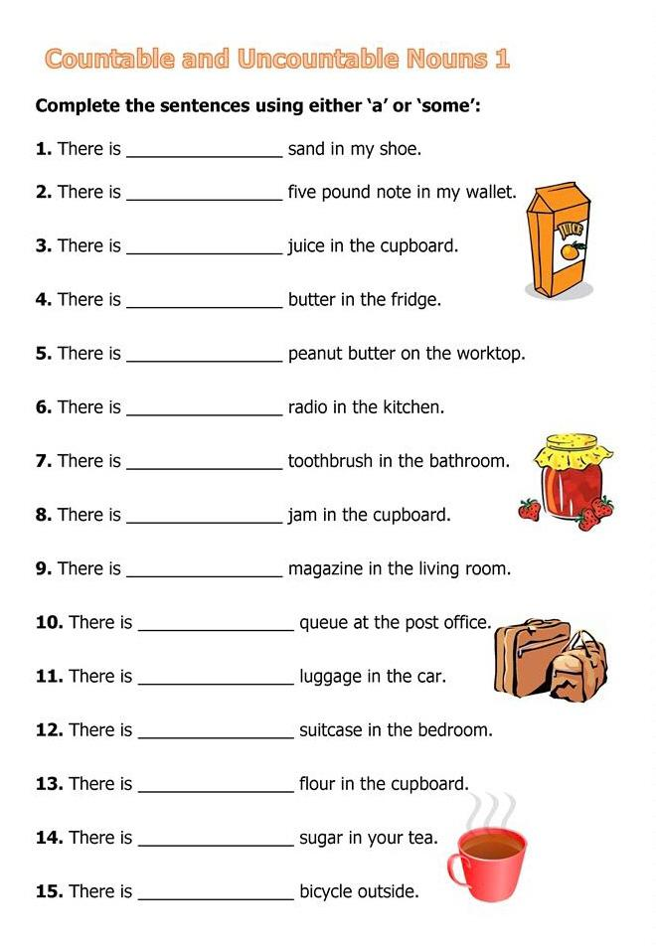

ANSWER

ANSWER

ANSWER

ANSWER

ANSWER

ANSWER

ANSWER

ANSWER

ANSWER

ANSWER

ANSWER

ANSWER

ANSWER

ANSWER

ANSWER

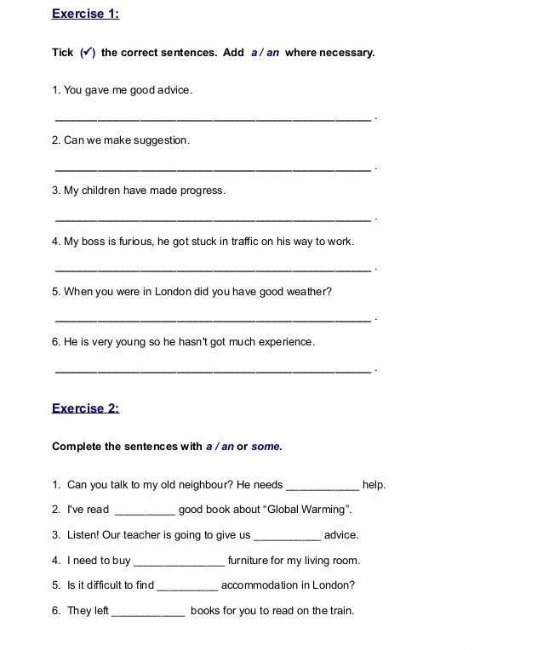

ANSWER

ANSWER

ANSWER

ANSWER

ANSWER

ANSWER

ANSWER

ANSWER

ANSWER

ANSWER

ANSWER

ANSWER

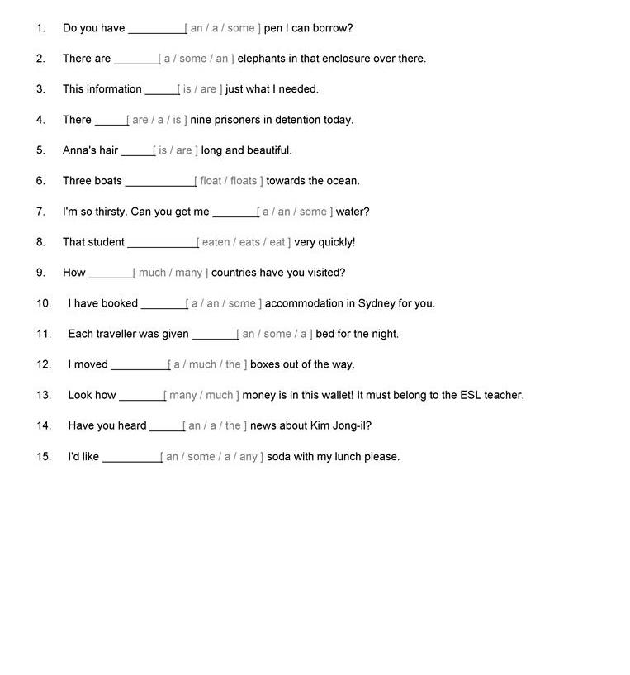

ANSWER

ANSWER

ANSWER

ANSWER

ANSWER

ANSWER

ANSWER

ANSWER

ANSWER

ANSWER

ANSWER

ANSWER

ANSWER

ANSWER

ANSWER