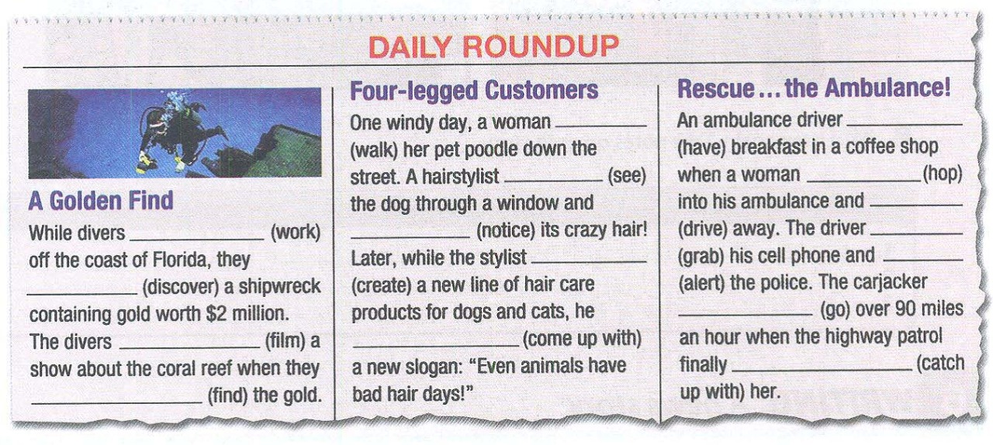

ANSWER

ANSWER

ANSWER

ANSWER

ANSWER

ANSWER

ANSWER

ANSWER

ANSWER

ANSWER

ANSWER

ANSWER

ANSWER

ANSWER

ANSWER

ANSWER